TRAVELFLOW
Albanian Riviera Transport & Tourism Platform

BUSINESS PROCESS MANAGEMENT
Complete Process Analysis · Yes/No Flowcharts · Improvement Plans

Document Type  BPM Analysis Report | System  TravelFlow Platform
Domain  Travel & Transport, Albania | Version  1.0 — Software Analysis & Design

1. Executive Summary

TravelFlow is a digital platform for premium bus travel and car rental services along the Albanian Riviera, connecting Tiranë, Himarë, and Sarandë. The system integrates six core operational domains: ticket booking, live GPS tracking, tourist guidance, car rental, fleet maintenance, and administrative control. This document analyses all business processes embedded within the platform, maps each one using a detailed Yes/No flowchart, identifies current weaknesses, and proposes targeted improvements.

Platform: TravelFlow — Albanian Riviera Travel Agency
Routes: 6 active routes across 17+ stops (Tiranë ↔ Himarë ↔ Sarandë)
Fleet: 6 buses (BUS001–BUS006) | 12 rental cars (CAR001–CAR012)
Staff: 6 drivers | 6 faturinos (ticket agents) | 4 office staff
User Roles: Guest visitor | Registered client | Admin
Technology: Single-page web application (HTML/JS/CSS), localStorage persistence
Flowcharts: All 9 processes modelled with Yes/No decision branches

2. Process Inventory

Nine top-level processes govern TravelFlow's operations. Each is analyzed with a dedicated Yes/No flowchart, step-by-step breakdown, problem log, improvement plan, and user scenario.

Process ID | Process Name | Actors Involved
BP-01 | User Registration & Authentication | Guest, System
BP-02 | Ticket Search & Booking | Client, System, Admin
BP-03 | Seat Selection & Payment | Client, System
BP-04 | Live GPS Tracking | Client, Driver, System
BP-05 | Car Rental | Client, Admin, System
BP-06 | Fleet Maintenance Management | Admin, Driver, System
BP-07 | Tourist Guide & Destination Discovery | Guest, Client
BP-08 | Administrative Dashboard & Reporting | Admin, System
BP-09 | Finance & Staff Scheduling | Admin, Accountant

Flowchart Legend:

Shape | Meaning | Color
Rounded rectangle / Ellipse | Start / End terminal | Teal (start) / Navy (end)
Rectangle | Process / Action step | Navy with teal border
Diamond | Decision point (Yes / No branch) | Gold / Amber
Parallelogram | Input / Output (user action) | Dark blue with teal border
Arrow labeled YES | Condition is true — continue flow | Green label
Arrow labeled NO | Condition is false — alternate path | Red label

3. BP-01 — User Registration & Authentication

PROCESS OVERVIEW

Registration and login are the gateway processes for the TravelFlow platform. The system supports two roles: Client (registered user) and Admin. Guests may browse routes, view the tourist guide, and explore car rentals without logging in, but cannot complete a booking or access account history.

3.1 Flowchart

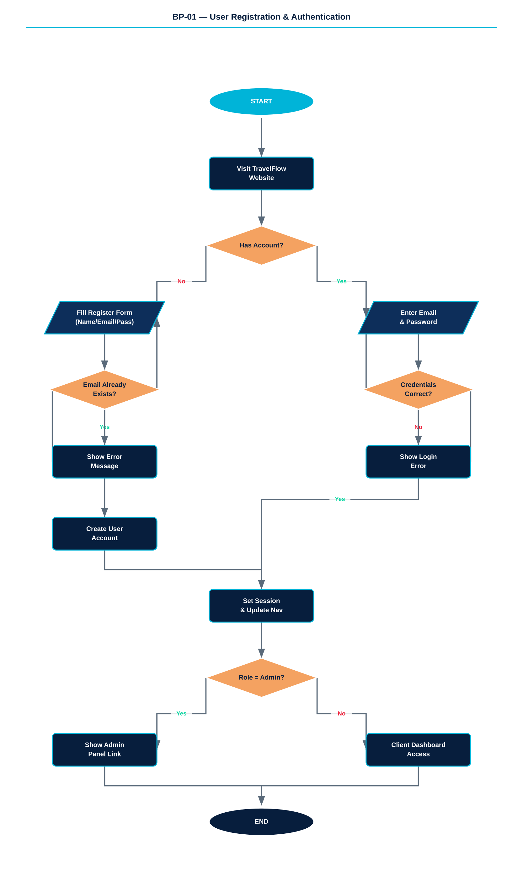

Figure 1 — User Registration & Authentication Yes/No Flowchart

3.2 Detailed Steps

The registration process requires the user to provide a full name, email address, and a password of at least six characters. Upon submission the system checks whether an account with the given email already exists. If the email is new, a user record is created with a unique ID and the role 'client'. Admin accounts are seeded directly into the system database and cannot be self-registered.

The login process accepts an email and password, searches the user store, and compares credentials. On success, the current user is stored in session state. The navigation bar updates immediately to show the user's name and avatar initials, and the Admin panel link becomes visible if the role is 'admin'.

Step | Actor | Action / System Response
1 | Guest | Opens TravelFlow and clicks 'Login' or 'Register'
2 | System | Displays authentication modal with Login / Register tabs
3 (Register) | Guest | Fills in: Full Name, Email, Password (min. 6 chars)
4 (Register) | System | Checks for duplicate email; creates user object with role='client'
5 (Login) | Client | Enters email and password
6 (Login) | System | Searches user store; compares password; sets session on match
7 | System | Closes modal, updates navigation bar, reveals account panel
8 (Admin) | Admin | Same login flow; 'Admin' link becomes visible in navigation

3.3 Identified Problems
PROBLEM 1: Passwords are stored in plain text within localStorage — no hashing or encryption.
PROBLEM 2: No email verification step — users can register with non-existent addresses.
PROBLEM 3: No password reset / 'Forgot Password' mechanism exists.
PROBLEM 4: Admin accounts are hardcoded — no interface to add or remove admins.
PROBLEM 5: Session is not persistent across browser tabs or restarts (in-memory only).

3.4 Recommended Improvements
FIX 1: Hash passwords using bcrypt or SHA-256 before storing.
FIX 2: Add email verification via a one-time token sent on registration.
FIX 3: Implement a password-reset flow tied to the registered email.
FIX 4: Allow admin to promote/demote users from the Admin > Users panel.
FIX 5: Persist session using secure cookies or JWT tokens.

3.5 User Scenario

Scenario: New customer first-time registration

A traveler from Tirana named Ersa hears about TravelFlow through a friend and wants to book a ticket to Sarandë. She opens the website and clicks 'Register'. A modal window slides open with a registration form. She types her full name, enters her email, and creates a password. After pressing 'Create Account' the system recognizes her as a new user and assigns her a client profile. The modal closes, and her name appears in the navigation bar alongside a small avatar. She is now ready to proceed to the booking section without any further steps.

Scenario: Returning admin login

Mirela, the platform manager, arrives at the office and needs to review overnight booking figures. She navigates to TravelFlow, clicks 'Login', and enters the admin email and password. The system validates her credentials and immediately reveals the Admin link in the navigation menu. She clicks it and lands on the Admin Dashboard where revenue statistics and active booking counts are already displayed.

4. BP-02 — Ticket Search & Booking

PROCESS OVERVIEW

This is the central revenue-generating process of TravelFlow. It covers the full journey from route discovery through trip selection, stop selection, and entry into the seat and payment pipeline. The system supports six bidirectional routes, with dynamic pricing based on the boarding and alighting stop.

4.1 Flowchart

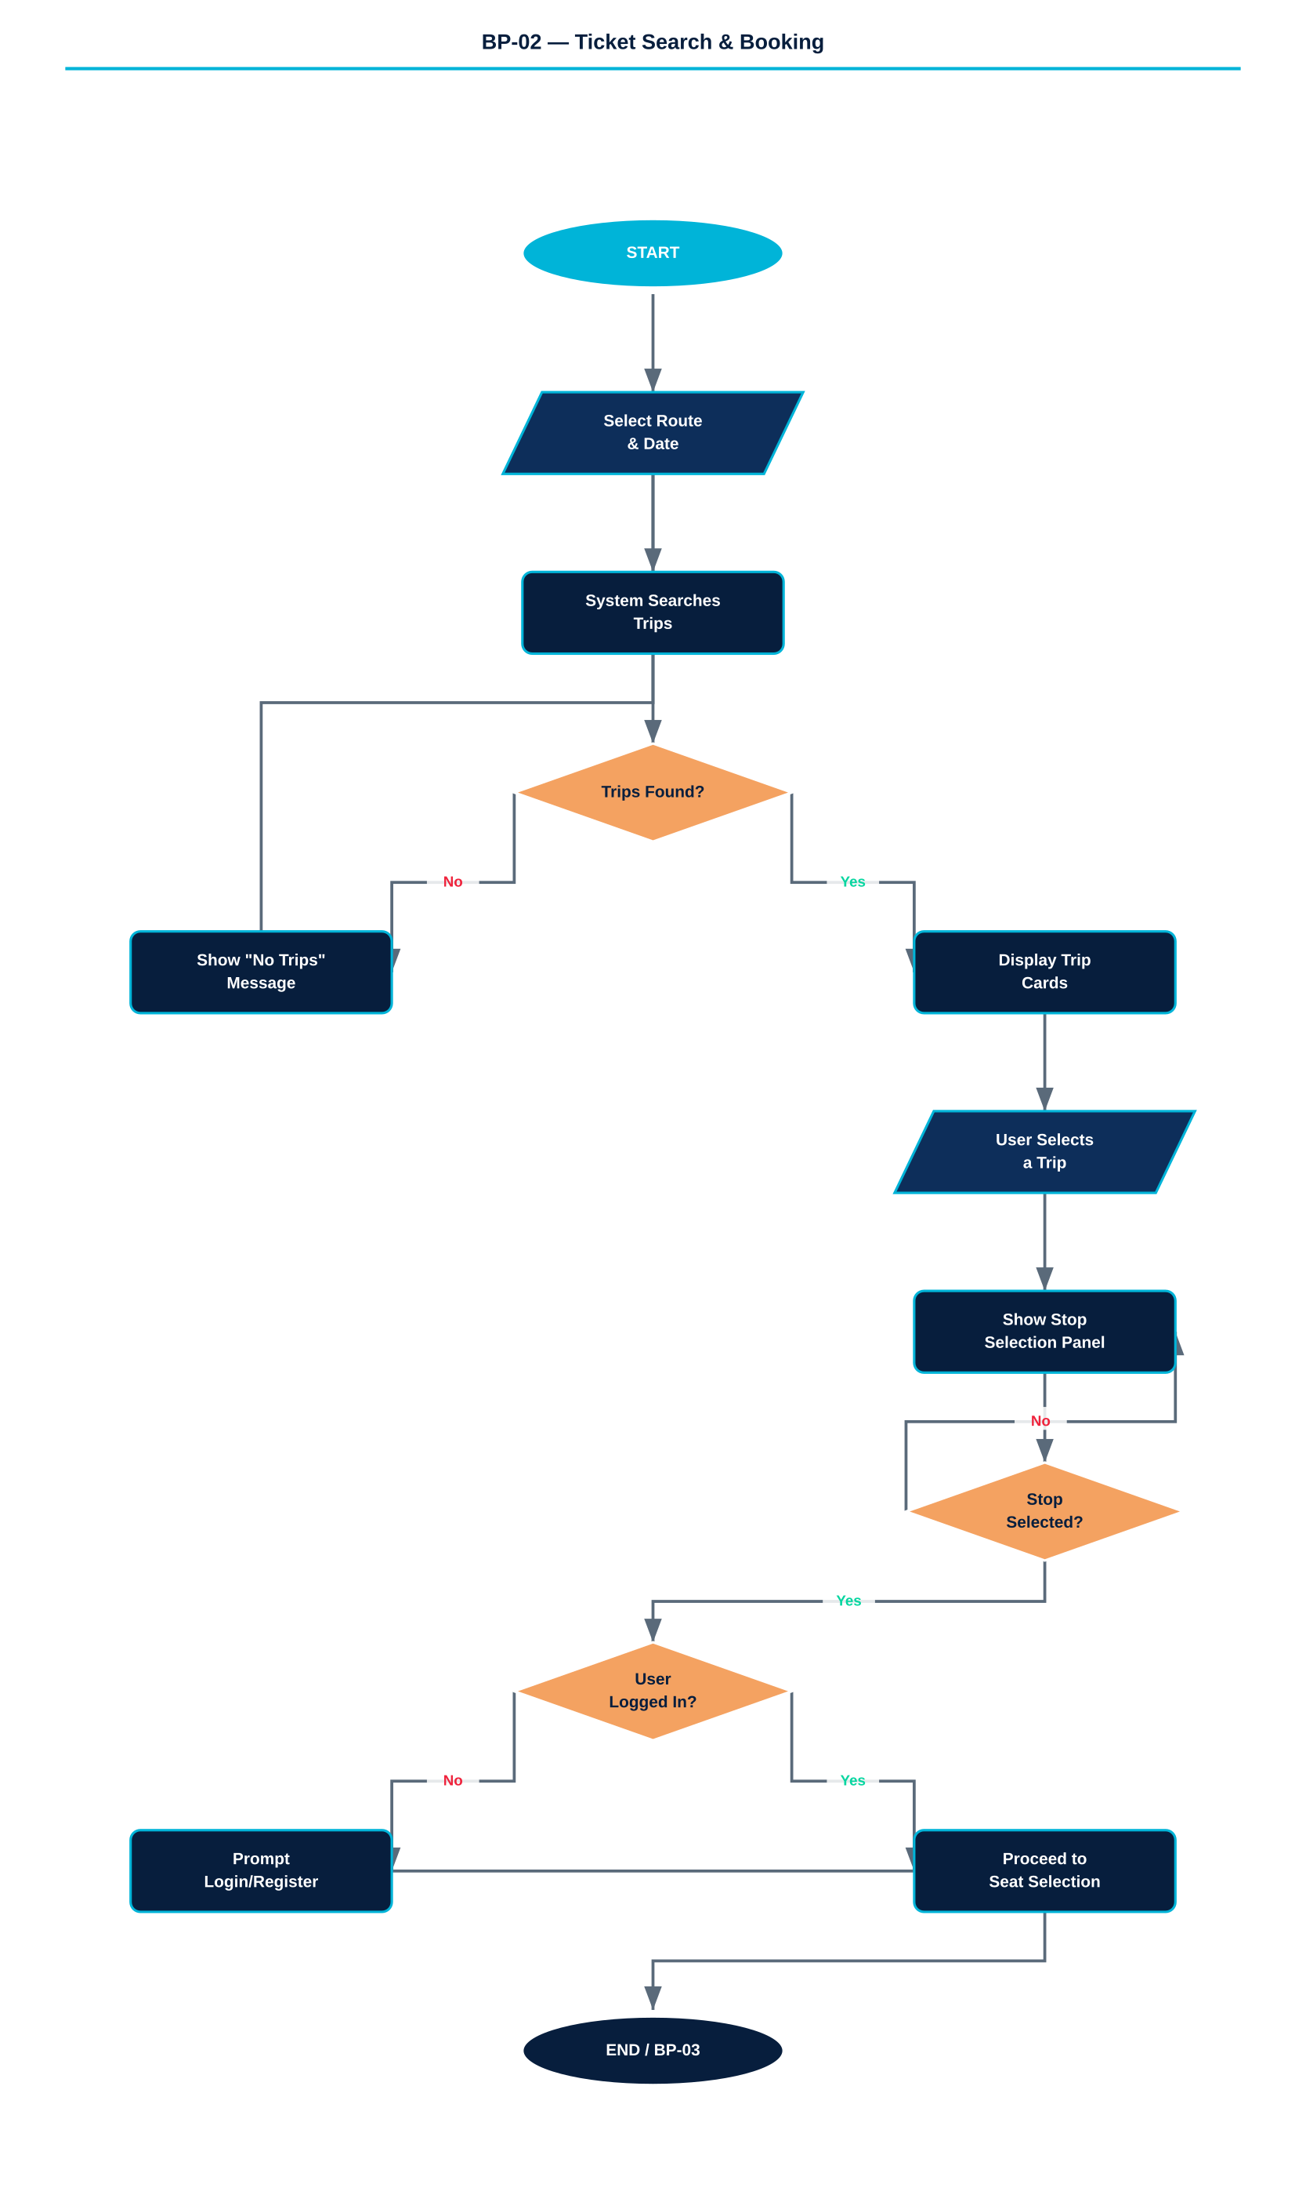

Figure 2 — Ticket Search & Booking Yes/No Flowchart

4.2 Routes & Stop Data

The platform operates six routes. Each has a fixed set of intermediate stops, each carrying a cumulative price in Albanian Lek (ALL). Passengers pay only for the distance actually travelled.

Route Code | Description
TR-HI | Tiranë → Himarë | ~4h 30min | ~234 km | From 1,000 ALL
TR-SA | Tiranë → Sarandë | ~5h 45min | ~284 km | From 1,000 ALL
HI-SA | Himarë → Sarandë | ~1h 30min | ~62 km | From 200 ALL
SA-HI | Sarandë → Himarë | ~1h 30min | ~62 km | From 100 ALL
SA-TR | Sarandë → Tiranë | ~5h 30min | ~284 km | From 100 ALL
HI-TR | Himarë → Tiranë | ~4h 30min | ~234 km | From 50 ALL

4.3 Detailed Steps
- User navigates to 'Book Tickets' from the navigation bar or homepage hero button.
- User selects an origin city, destination city, and travel date from the search form.
- System queries all trips matching the selected route and date; displays available trip cards with departure time, estimated arrival, duration, available seats, and price range.
- User clicks a trip card to initiate the booking. A stop-selection panel expands.
- Each stop card shows stop name, estimated time, distance, and the price to alight there. Hot/popular stops are highlighted in green; the final destination is highlighted in gold.
- User selects their alighting stop; the card highlights with a teal border.
- If the user is not logged in, a prompt to login/register appears before continuing.
- System proceeds to the seat selection modal (BP-03).

4.4 Identified Problems
PROBLEM 1: No multi-passenger booking — each booking is for exactly one seat.
PROBLEM 2: No return trip functionality — users must book each direction separately.
PROBLEM 3: Date validation is minimal — past dates are not clearly blocked.
PROBLEM 4: No email confirmation or booking reference sent to the client.
PROBLEM 5: Trip availability is not enforced until seat selection.
PROBLEM 6: Search requires exact route match — no flexible or partial-route search.

4.5 Recommended Improvements
FIX 1: Add a passenger count selector (1–6) with group pricing.
FIX 2: Introduce a 'Return trip' checkbox that opens a second date and route selection.
FIX 3: Disable past dates in the date picker and show a warning if a trip is full.
FIX 4: Send booking confirmation email with QR code and booking reference.
FIX 5: Lock seat capacity checks at the trip level before opening seat selection.
FIX 6: Add flexible search that lists all trips from a city on a selected date.

4.6 User Scenario

Scenario: Traveler booking a trip to Dhërmi

Arben, a Tirana resident, wants to visit Dhërmi for the weekend. He opens TravelFlow and navigates to 'Book Tickets'. He selects Tiranë as his origin, Himarë as his destination, and picks the upcoming Saturday. The system displays four available trips for that day. He chooses the 08:00 departure to maximize beach time. The stop panel expands, and he spots Dhërmi — marked as a hot stop in green at 1,200 ALL. He clicks the Dhërmi card, which highlights in teal, and proceeds to seat selection.

5. BP-03 — Seat Selection & Payment

PROCESS OVERVIEW

Once the user has chosen a trip and a destination stop, this two-stage modal process offers a seat assignment choice, collects payment details, and issues a digital ticket.

5.1 Flowchart

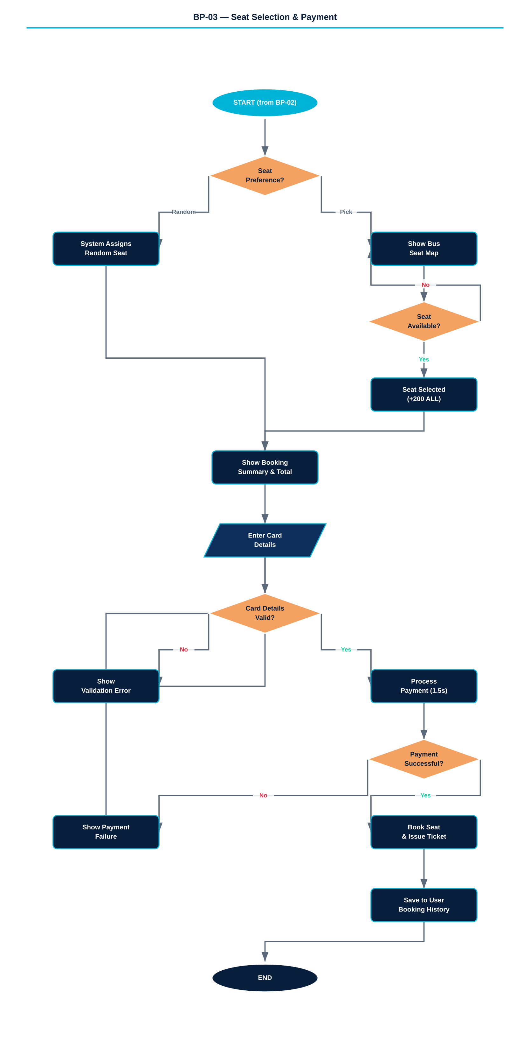

Figure 3 — Seat Selection & Payment Yes/No Flowchart

5.2 Seat Assignment Options
Option | Details
Random Seat (FREE) | System automatically assigns an available seat at no extra charge. A random seat is selected from the bus layout and highlighted in gold.
Pick My Seat (+200 ALL) | User is shown a full interactive bus layout. Green = available, grey = taken, teal = currently selected. User clicks a seat to choose it.

5.3 Payment Flow
- System displays booking summary: route, departure time, stop, seat number, base fare, seat selection fee (if applicable), and total.
- User enters cardholder name, card number (16 digits), expiry date (MM/YY), and CVV.
- User clicks 'Pay Now'. A loading spinner is shown for 1.5 seconds to simulate processing.
- On success, the seat is registered as booked on the trip record, and a digital ticket is generated.
- Ticket displays: TRAVELFLOW branding, unique booking code, origin/destination, date, departure time, seat number, and a QR code placeholder.
- Booking is stored in the user's account history.

5.4 Fee Breakdown
Fee Component | Amount
Base Fare (distance-based) | From 50 ALL to 1,500 ALL depending on selected stop
Seat Selection Fee (optional) | +200 ALL for manual seat picking
Service / Platform Fee | 0 ALL (currently not applied)
Total | Base Fare + optional 200 ALL

5.5 Identified Problems
PROBLEM 1: Payment is fully simulated — no real payment gateway is integrated.
PROBLEM 2: Card details are entered but not validated (no Luhn algorithm check).
PROBLEM 3: No invoice or receipt document is generated or stored.
PROBLEM 4: Ticket QR code is decorative only — no real barcode data is encoded.
PROBLEM 5: No VAT calculation despite it being legally required in Albania.
PROBLEM 6: Double-booking is possible if two users select the same seat simultaneously.

5.6 Recommended Improvements
FIX 1: Integrate a real payment provider (Stripe or Raiffeisen Bank Albania API).
FIX 2: Validate card number using the Luhn algorithm before submission.
FIX 3: Generate a PDF receipt with booking details and email it to the client.
FIX 4: Generate a real QR code (e.g. via qrcode.js) encoding the booking ID.
FIX 5: Apply and display VAT (20% standard Albanian rate) in the fee breakdown.
FIX 6: Implement optimistic locking — reserve the seat for 5 minutes during payment.

5.7 User Scenario

Scenario: First-time traveler choosing a window seat

After selecting the Dhërmi stop on the 08:00 trip from Tiranë, Ersa is presented with the seat selection modal. She decides she would like a window seat for the scenic coastal views. She selects 'Pick My Seat' and pays the 200 ALL fee. The bus layout appears on screen, showing a mix of available green seats and a few grey taken ones. She clicks seat 5A — a left-side window seat near the front. It highlights in teal. She reviews the booking summary confirming 1,200 ALL plus 200 ALL seat fee for a total of 1,400 ALL, enters her card details, and clicks 'Pay Now'. A brief loading screen appears, followed by her digital ticket with a unique code and QR placeholder. She screenshots it for the journey.

6. BP-04 — Live GPS Tracking

PROCESS OVERVIEW

The Live GPS Tracking module provides real-time vehicle location for all six active buses and twelve rental cars on an interactive Leaflet.js map. Users can track any vehicle and see its current position animated along its route waypoints.

6.1 Flowchart

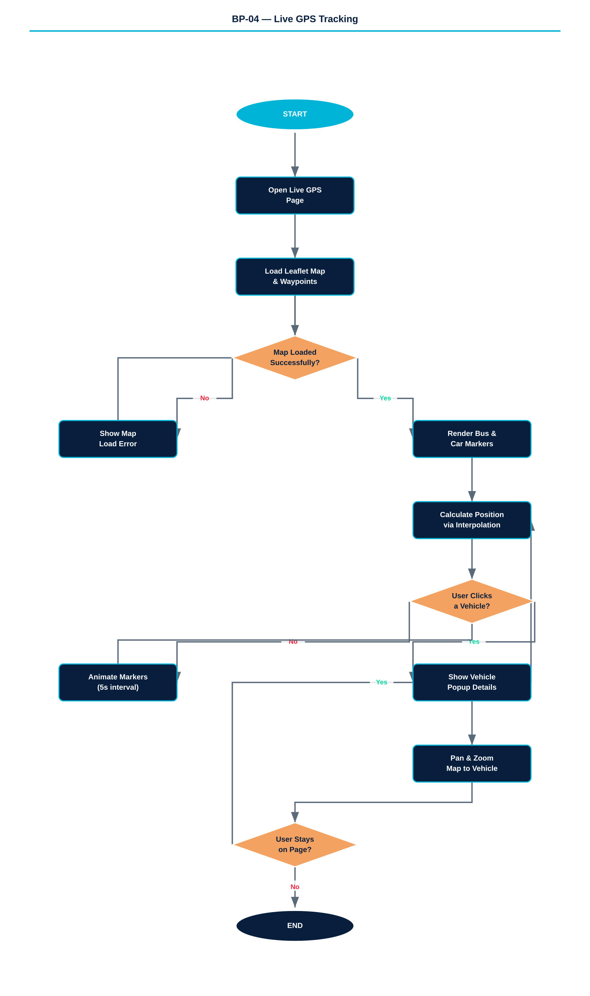

Figure 4 — Live GPS Tracking Yes/No Flowchart

6.2 Technical Architecture
Component | Description
Map Provider | Leaflet.js with OpenStreetMap tile layer
Bus Marker | Circular teal marker with pulsing animation
Car Marker | Circular gold marker with pulsing animation
Position Algorithm | Cumulative distance interpolation along waypoint array
Update Interval | Every 5 seconds (simulated movement)
Popup Content | Vehicle ID, route, plate, status (Moving/Stopped), driver name
Sidebar | Scrollable list of all vehicles with 'Focus on map' button

6.3 Identified Problems
PROBLEM 1: GPS positions are simulated using time interpolation — no real GPS device integration.
PROBLEM 2: Bus drivers have no app or interface to report actual position or delays.
PROBLEM 3: Map tiles require internet access — no offline fallback for rural areas.
PROBLEM 4: No estimated arrival time (ETA) shown per stop based on current position.
PROBLEM 5: No alerts or notifications for passengers when their bus is approaching.
PROBLEM 6: Rental car routes are pre-defined — cars do not follow actual road paths.

6.4 Recommended Improvements
FIX 1: Integrate a GPS hardware device (e.g. SIM7600 module) with REST API push to server.
FIX 2: Develop a lightweight mobile app for drivers to share GPS position every 10 seconds.
FIX 3: Cache map tiles using a service worker for offline functionality.
FIX 4: Calculate and display dynamic ETAs for each stop based on interpolated current speed.
FIX 5: Send SMS or push notification to passengers when bus is within 3 km of their stop.
FIX 6: Use a free-routing API (OSRM or Valhalla) for car routes based on the road network.

6.5 User Scenario

Scenario: Passenger tracking a bus from Sarandë

Jona has a ticket on the SA-TR bus departing Sarandë this morning. She is still at breakfast and wants to check how far along the bus is before heading to the stop. She opens TravelFlow on her phone and taps 'Live GPS'. The map loads and she immediately sees animated teal markers moving along the coastal road. She spots BUS004 in the sidebar list and taps 'Focus on map'. The map pans and zooms to the bus marker, showing a popup with the bus plate, route, and current status as 'Moving'. She estimates from the position on the map that the bus is still 15 minutes from her stop and finishes her coffee unhurriedly.

7. BP-05 — Car Rental

PROCESS OVERVIEW

The Car Rental module allows registered clients to browse a fleet of 12 GPS-tracked vehicles and reserve a car for a defined period. The fleet spans economy, compact, SUV, off-road, and luxury categories, priced from 36 to 95 EUR per day.

7.1 Flowchart

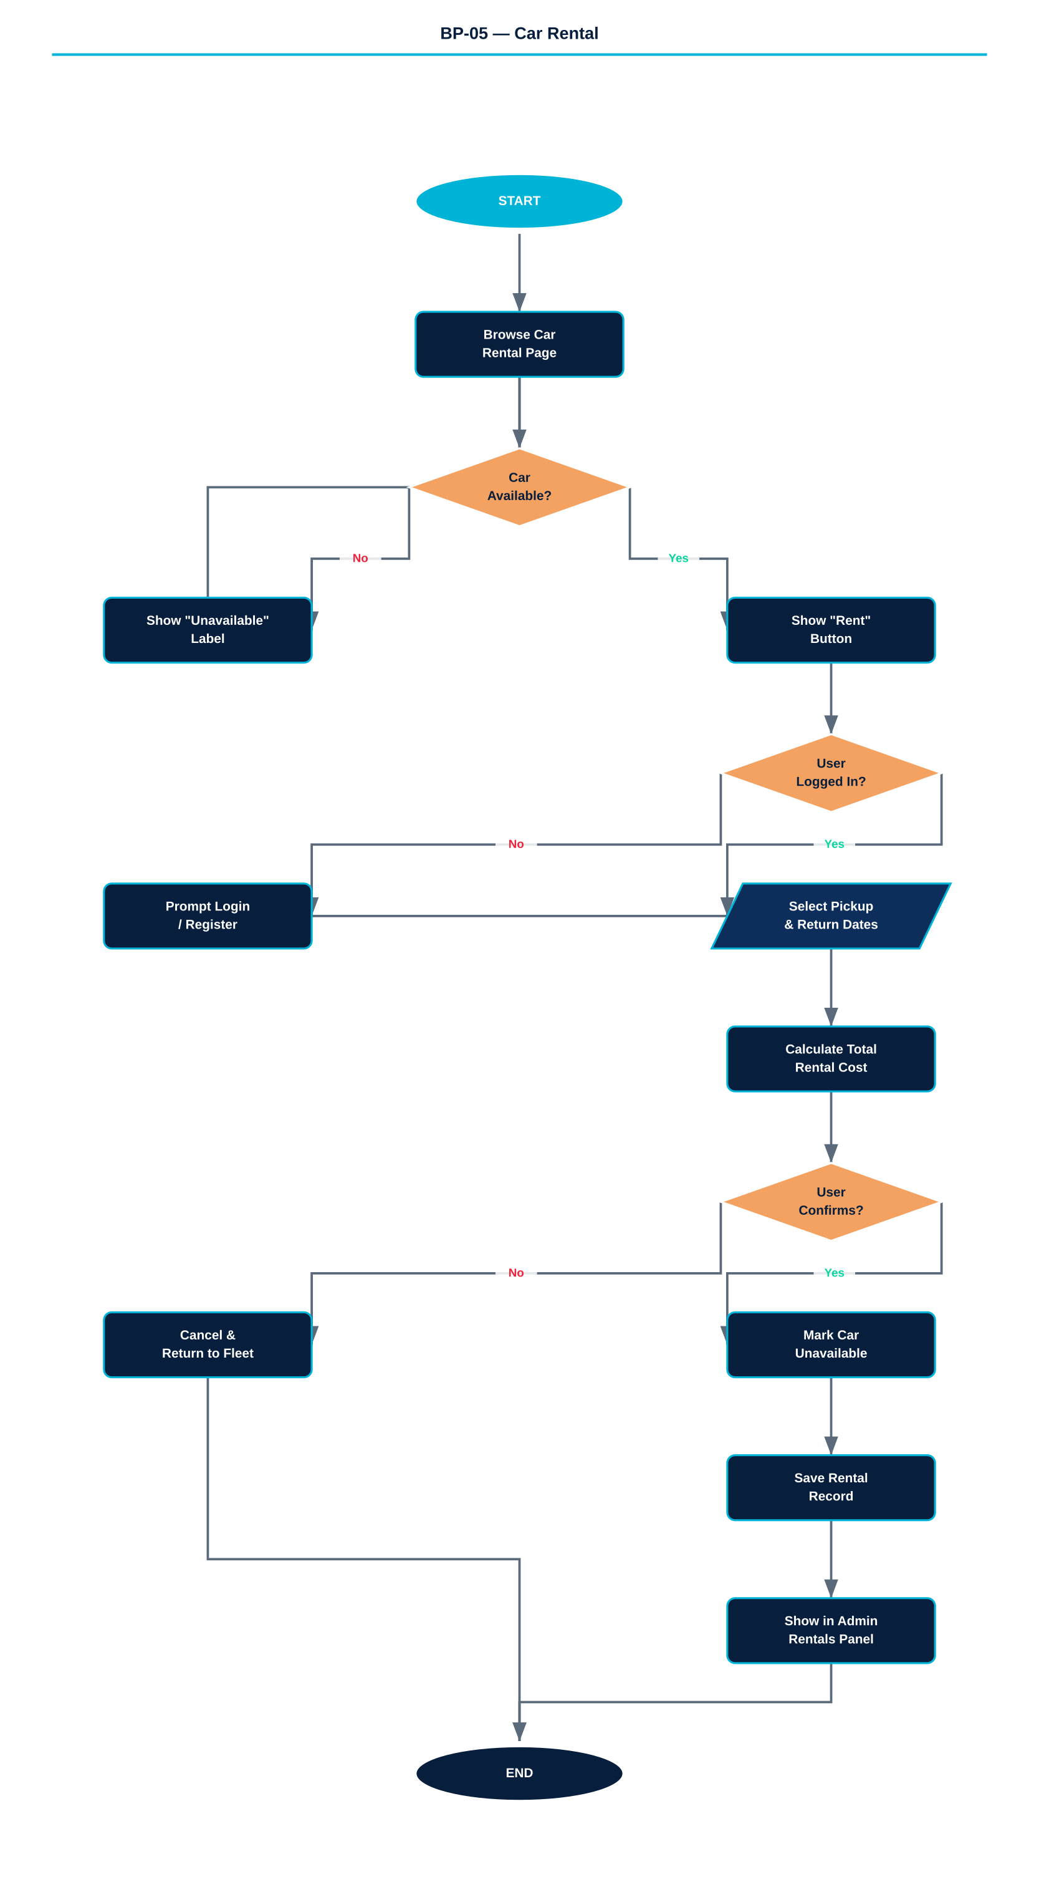

Figure 5 — Car Rental Yes/No Flowchart

7.2 Fleet Overview
Category | Vehicles | Price Range / Day
Economy | Toyota Corolla, Skoda Octavia, Renault Megane, Ford Focus | 36 – 42 EUR
Compact | VW Golf, Ford Focus | 38 – 45 EUR
SUV | BMW X3, Hyundai Tucson, Kia Sportage, Nissan Qashqai | 52 – 80 EUR
Off-Road | Jeep Wrangler | 70 EUR
Luxury | Mercedes C-Class, Audi A6 | 90 – 95 EUR

7.3 Detailed Steps
- User navigates to the 'Car Rental' page from the main navigation.
- Fleet grid displays all 12 cars with photo/emoji placeholder, category badge, availability indicator (green/red dot), specifications (fuel, transmission, seats), and daily price.
- User selects an available car by clicking the 'Rent' button.
- A rental modal opens: user selects pickup date and return date, total cost is calculated automatically.
- User confirms the rental. The system marks the car as unavailable and logs the rental record under the user's account.
- Admin can view all active rentals from the Admin > Rentals panel.

7.4 Identified Problems
PROBLEM 1: No driver's license verification or age check before confirming rental.
PROBLEM 2: No real-time availability calendar — only a binary available/unavailable flag.
PROBLEM 3: Rental insurance and damage deposit are not documented or collected.
PROBLEM 4: Car photos are optional — many cars display only an emoji placeholder.
PROBLEM 5: No pickup/return location or time selection — defaults are not defined.
PROBLEM 6: No cancellation or modification flow exists once a rental is confirmed.
PROBLEM 7: Admin can manually mark cars unavailable but there is no automated return process.

7.5 Recommended Improvements
FIX 1: Add an upload field for driver's license (front and back) as part of the rental form.
FIX 2: Implement a date-range availability calendar showing booked periods visually.
FIX 3: Add a mandatory security deposit step and pre-authorize the card on file.
FIX 4: Require a minimum of one real photo per car; flag cars without photos in the Admin panel.
FIX 5: Add pickup office location selector and preferred pickup time.
FIX 6: Allow cancellations up to 24 hours before pickup with automatic availability reset.
FIX 7: Automate car return: when the return date passes, the system re-marks the car as available.

7.6 User Scenario

Scenario: Tourist renting an off-road vehicle for Riviera exploration

Marco is an adventure traveler visiting Albania and lands in Tirana. He wants to explore the less accessible mountain trails above the Riviera without being dependent on bus schedules. He opens TravelFlow and navigates to Car Rental. He spots the Jeep Wrangler at 70 EUR/day with a green availability dot. He clicks 'Rent', selects a five-day rental period, and the system shows a total of 350 EUR. He confirms the booking. The Jeep is now marked as unavailable for other users, and a rental record appears in his account. He calls the office number displayed on the website to arrange a pickup location.

8. BP-06 — Fleet Maintenance Management

PROCESS OVERVIEW

TravelFlow includes a dedicated maintenance tracking module for all six buses and twelve rental cars. Each vehicle has a service schedule covering oil changes, tyre rotation, brake inspection, annual technical inspection, insurance renewal, and roadworthiness certification.

8.1 Flowchart

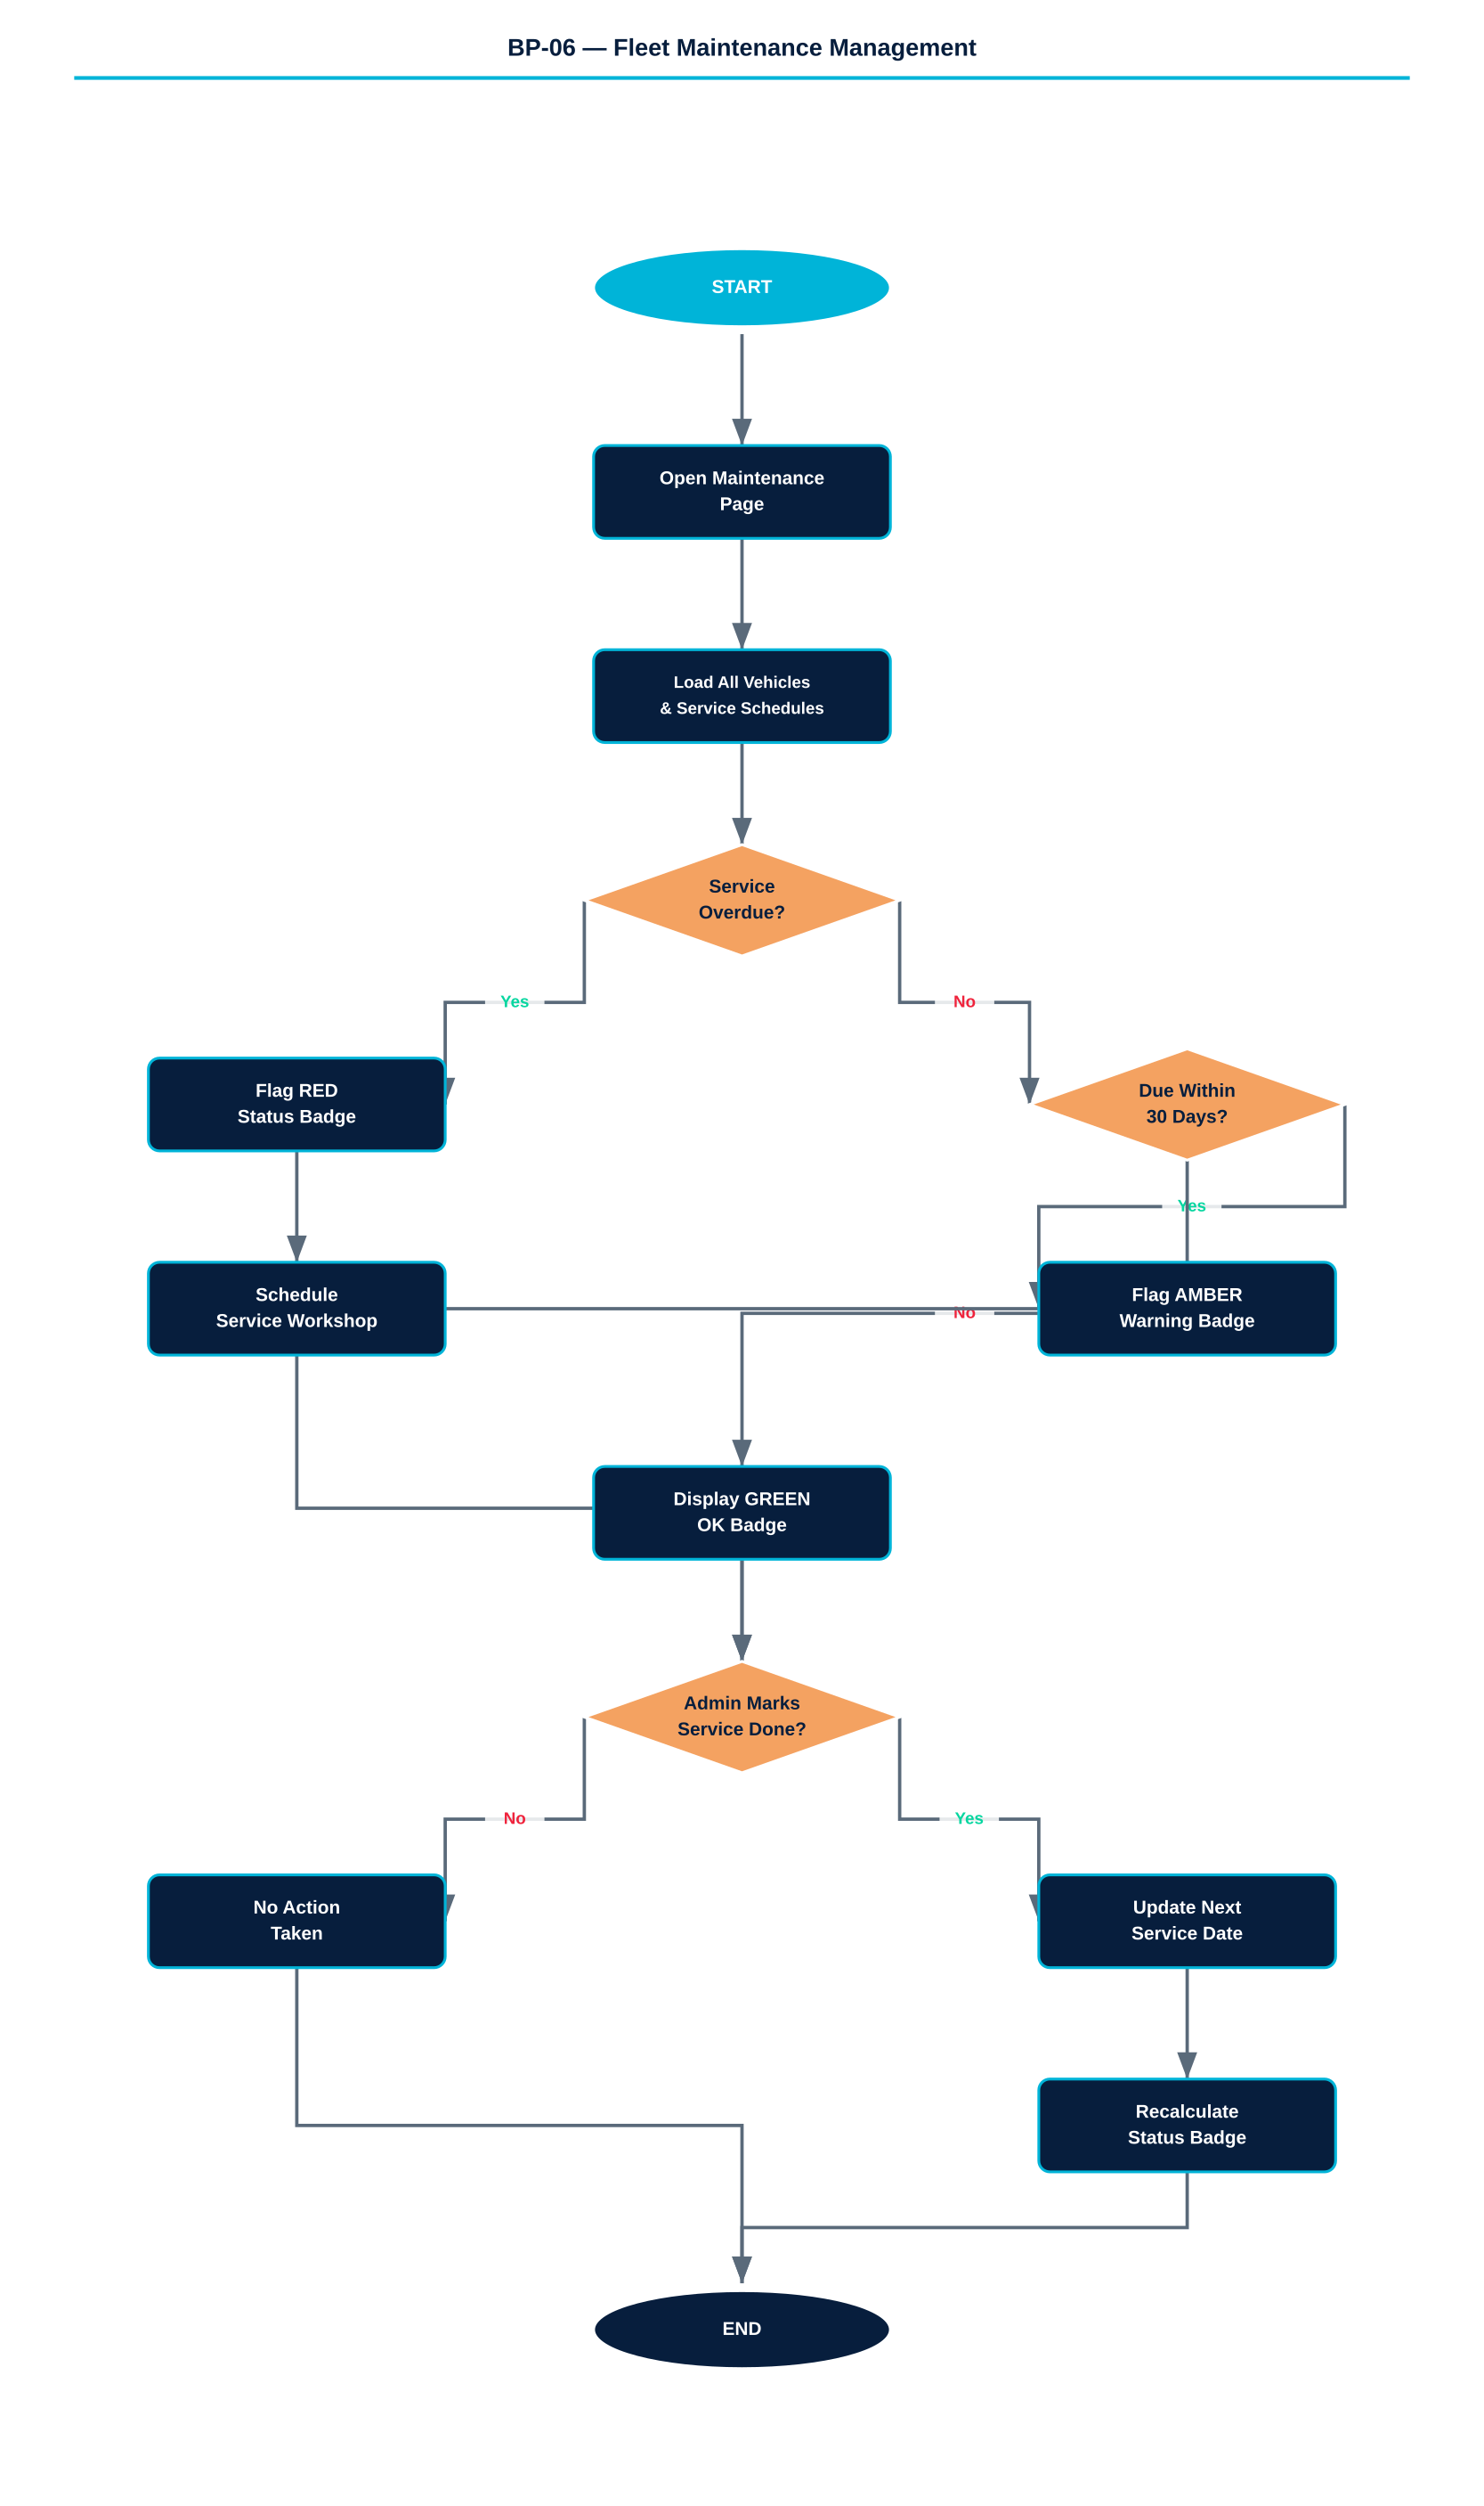

Figure 6 — Fleet Maintenance Management Yes/No Flowchart

8.2 Service Types Tracked
Service Name (Albanian) | Interval
Ndërrimi i Vajit — Oil Change | Every 90 days
Rotacioni i Gomave — Tyre Rotation | Every 90 days
Kontrolli i Frenave — Brake Inspection | Every 180 days
Inspektimi Vjetor — Annual Technical Inspection | Every 365 days
Sigurimi — Insurance Renewal | Every 365 days
Kolaudimi — Roadworthiness Certificate | Every 365 days

8.3 Status Indicators
Status Badge | Meaning
GREEN (OK) | Next service due in more than 30 days
AMBER (Warning) | Next service due within 30 days
RED (Overdue) | Service date has passed — vehicle may be non-compliant

8.4 Identified Problems
PROBLEM 1: Maintenance records are stored only in localStorage — data is lost if the browser is cleared.
PROBLEM 2: No automated alert system — admins must manually check the maintenance page.
PROBLEM 3: No integration with external service workshops or repair booking systems.
PROBLEM 4: Marking a service as 'done' updates a checkbox but does not auto-advance the next due date.
PROBLEM 5: No maintenance history log — no way to audit what was done and when.
PROBLEM 6: Overdue vehicles are not taken out of service — buses can still appear in trip search.

8.5 Recommended Improvements
FIX 1: Migrate maintenance records to a server-side database (e.g. PostgreSQL).
FIX 2: Send automated email/SMS alerts to admin when any service enters 'Warning' status.
FIX 3: Add a 'Schedule Workshop Appointment' button that integrates with an external calendar.
FIX 4: When admin checks a service, auto-calculate and set the next due date from today + interval.
FIX 5: Maintain a full service history log with timestamps and technician notes.
FIX 6: Flag overdue buses in the Admin Dashboard and prevent them from appearing in trip search.

8.6 User Scenario

Scenario: Admin discovering an overdue service

Mirela, the platform manager, starts her Monday morning routine by opening the Maintenance page. She sees BUS002 highlighted with a red status badge — the tyre rotation is five days overdue. She clicks the vehicle card, reviews the service record, and realizes the rotation was missed during a busy weekend. She calls the designated workshop and schedules the service for the following morning. Once the mechanic confirms completion, she checks the service off, and the next scheduled rotation date automatically advances 90 days.

9. BP-07 — Tourist Guide & Destination Discovery

PROCESS OVERVIEW

The Tourist Guide module serves as an integrated destination marketing tool, allowing visitors — registered or not — to explore key destinations along the Albanian Riviera. It presents curated destination cards with descriptions, highlights, and visual imagery.

9.1 Flowchart

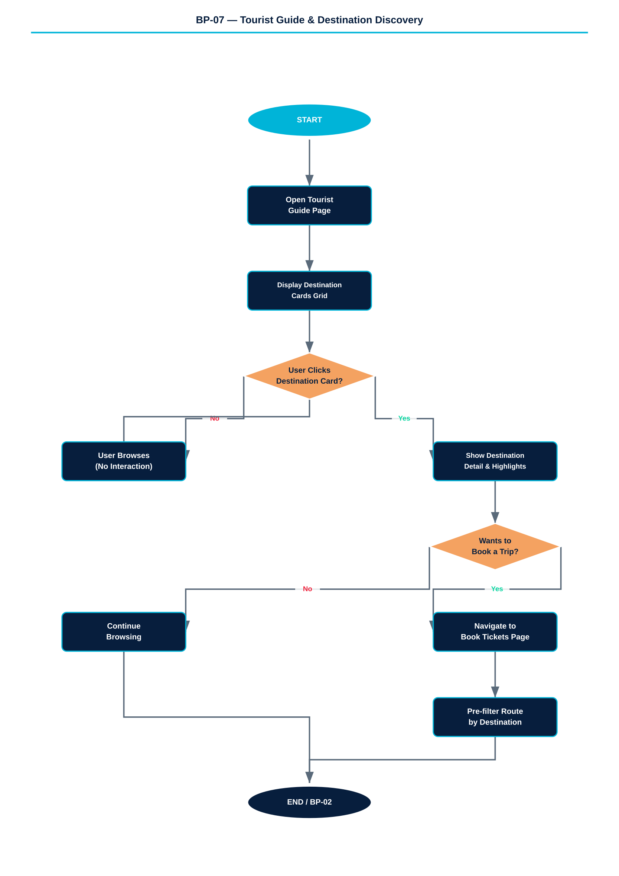

Figure 7 — Tourist Guide & Destination Discovery Yes/No Flowchart

9.2 Destinations Covered
Destination | Key Highlights
Sarandë | Seaside promenade, Lekuresi Castle, Ksamil Islands, Butrint UNESCO site
Himarë | Ancient fortress, pristine beaches, fresh seafood, sunsets over Corfu
Dhërmi | Crystal-clear turquoise bay, beach clubs, snorkelling, party atmosphere
Riviera Shqiptare | 170 km of coastline, olive groves, fishing villages, mountain views
Llogara Pass | 1,043 m altitude, national park, paragliding, eagle-eye coastal panorama
Porto Palermo | Ottoman-era castle on a peninsula, submarine base history, secluded bay
Himarë Old Quarter | Byzantine-era upper town, traditional Albanian stone architecture

9.3 Identified Problems
PROBLEM 1: All destination images are CSS gradient placeholders — no real photography.
PROBLEM 2: No deep-link from a destination card to a filtered trip search for that stop.
PROBLEM 3: No user reviews or ratings for destinations.
PROBLEM 4: Seasonal recommendations are hardcoded ('Summer', 'All Year') with no dynamic data.
PROBLEM 5: No multi-language support — content is in English only.

9.4 Recommended Improvements
FIX 1: Add an admin photo upload panel for each destination card.
FIX 2: Add a 'Book a trip here' button that opens the booking form pre-filtered for that stop.
FIX 3: Add a 5-star rating and short review system visible to all users.
FIX 4: Pull seasonal weather data from an API to dynamically update visit recommendations.
FIX 5: Add an Albanian (Shqip) language toggle across the full platform.

9.5 User Scenario

Scenario: Undecided tourist exploring options

A French couple visiting Albania for the first time opens TravelFlow to decide where to spend their three days. They navigate to the Tourist Guide page and scroll through the destination cards. They are immediately drawn to the Llogara Pass card, which mentions a 1,043-metre altitude with panoramic coastal views. They read the highlights, note that it is marked as an all-year destination, and inspired, they click back to the booking page and search for trips from Tiranë to Himarë. They choose Llogara Pass as their alighting stop and complete the booking entirely within the platform.

10. BP-08 — Administrative Dashboard & Reporting

PROCESS OVERVIEW

The Admin Dashboard is the operational control center of TravelFlow, accessible only to admin-role users. It consolidates nine management panels covering buses, routes, bookings, users, car GPS management, rentals, maintenance, and finances.

10.1 Flowchart

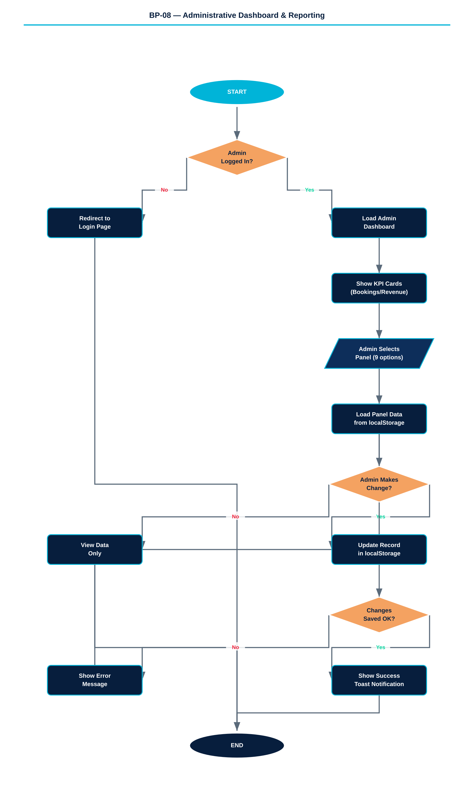

Figure 8 — Administrative Dashboard Yes/No Flowchart

10.2 Admin Panel Inventory
Panel | Primary Function | Key Data Shown
Dashboard | KPI overview | Total bookings, revenue today, active buses, cars rented
Buses | Fleet management | Bus ID, plate, model, route, capacity, status
Routes | Route configuration | Route codes, cities, stop counts, daily revenue
Bookings | Booking management | All bookings, client name, route, date, seat, amount
Users | User management | User list, role, email, registration date
Cars GPS | Rental car configuration | Car ID, plate, GPS routes, photo upload, availability toggle
Rentals | Active rental management | Active/completed rentals, client, dates, revenue
Maintenance | Fleet service tracking | Service status per vehicle, overdue alerts
Finances | Revenue & cost analysis | Daily revenue, monthly trends, staff costs, profit margin

10.3 Dashboard KPIs
- Total Bookings — cumulative number of completed bookings across all routes.
- Revenue Today — sum of all payments processed on the current calendar day.
- Active Buses — number of buses currently in 'active' status.
- Cars Rented — number of vehicles with available:false status from the rental fleet.

10.4 Identified Problems
PROBLEM 1: Admin panel is protected only by role check in client-side JS — no server authentication.
PROBLEM 2: All data is in localStorage — concurrent admin sessions in multiple browsers will conflict.
PROBLEM 3: No audit log of admin actions (edits, deletions, status changes).
PROBLEM 4: No export functionality — data cannot be downloaded as CSV, PDF, or Excel.
PROBLEM 5: No access control between admin sub-roles (e.g. accountant vs. operations manager).
PROBLEM 6: Dashboard KPIs are computed from localStorage — not reliable for reporting purposes.

10.5 Recommended Improvements
FIX 1: Implement server-side JWT authentication with role-based API endpoint guards.
FIX 2: Migrate to a backend database; admin session should work across all devices.
FIX 3: Add a full audit trail: log every admin action with timestamp, user, and change details.
FIX 4: Add export buttons (CSV and PDF) on all admin data tables.
FIX 5: Define sub-roles: Operations Manager, Accountant, IT Admin — each with restricted views.
FIX 6: Connect KPI cards to aggregated database queries rather than localStorage scans.

10.6 User Scenario

Scenario: Operations manager reviewing a busy Friday

Mirela opens the Admin Dashboard on Friday afternoon to review the day's performance. The KPI row shows 47 bookings and 184,000 ALL in revenue — a strong day. She clicks into the Bookings panel and scrolls through the list, noting that the SA-TR route is the most booked. She then navigates to the Maintenance panel to ensure all six buses are showing green status before the weekend peak. Two buses show amber warnings — oil changes due next week. She notes these for the mechanic and closes the browser satisfied.

11. BP-09 — Finance & Staff Scheduling

PROCESS OVERVIEW

The Finance module provides revenue tracking, cost analysis, and staff salary management. It combines route-level revenue estimates, staff payroll, vehicle running costs, and profit margin calculation in a single admin-only panel.

11.1 Flowchart

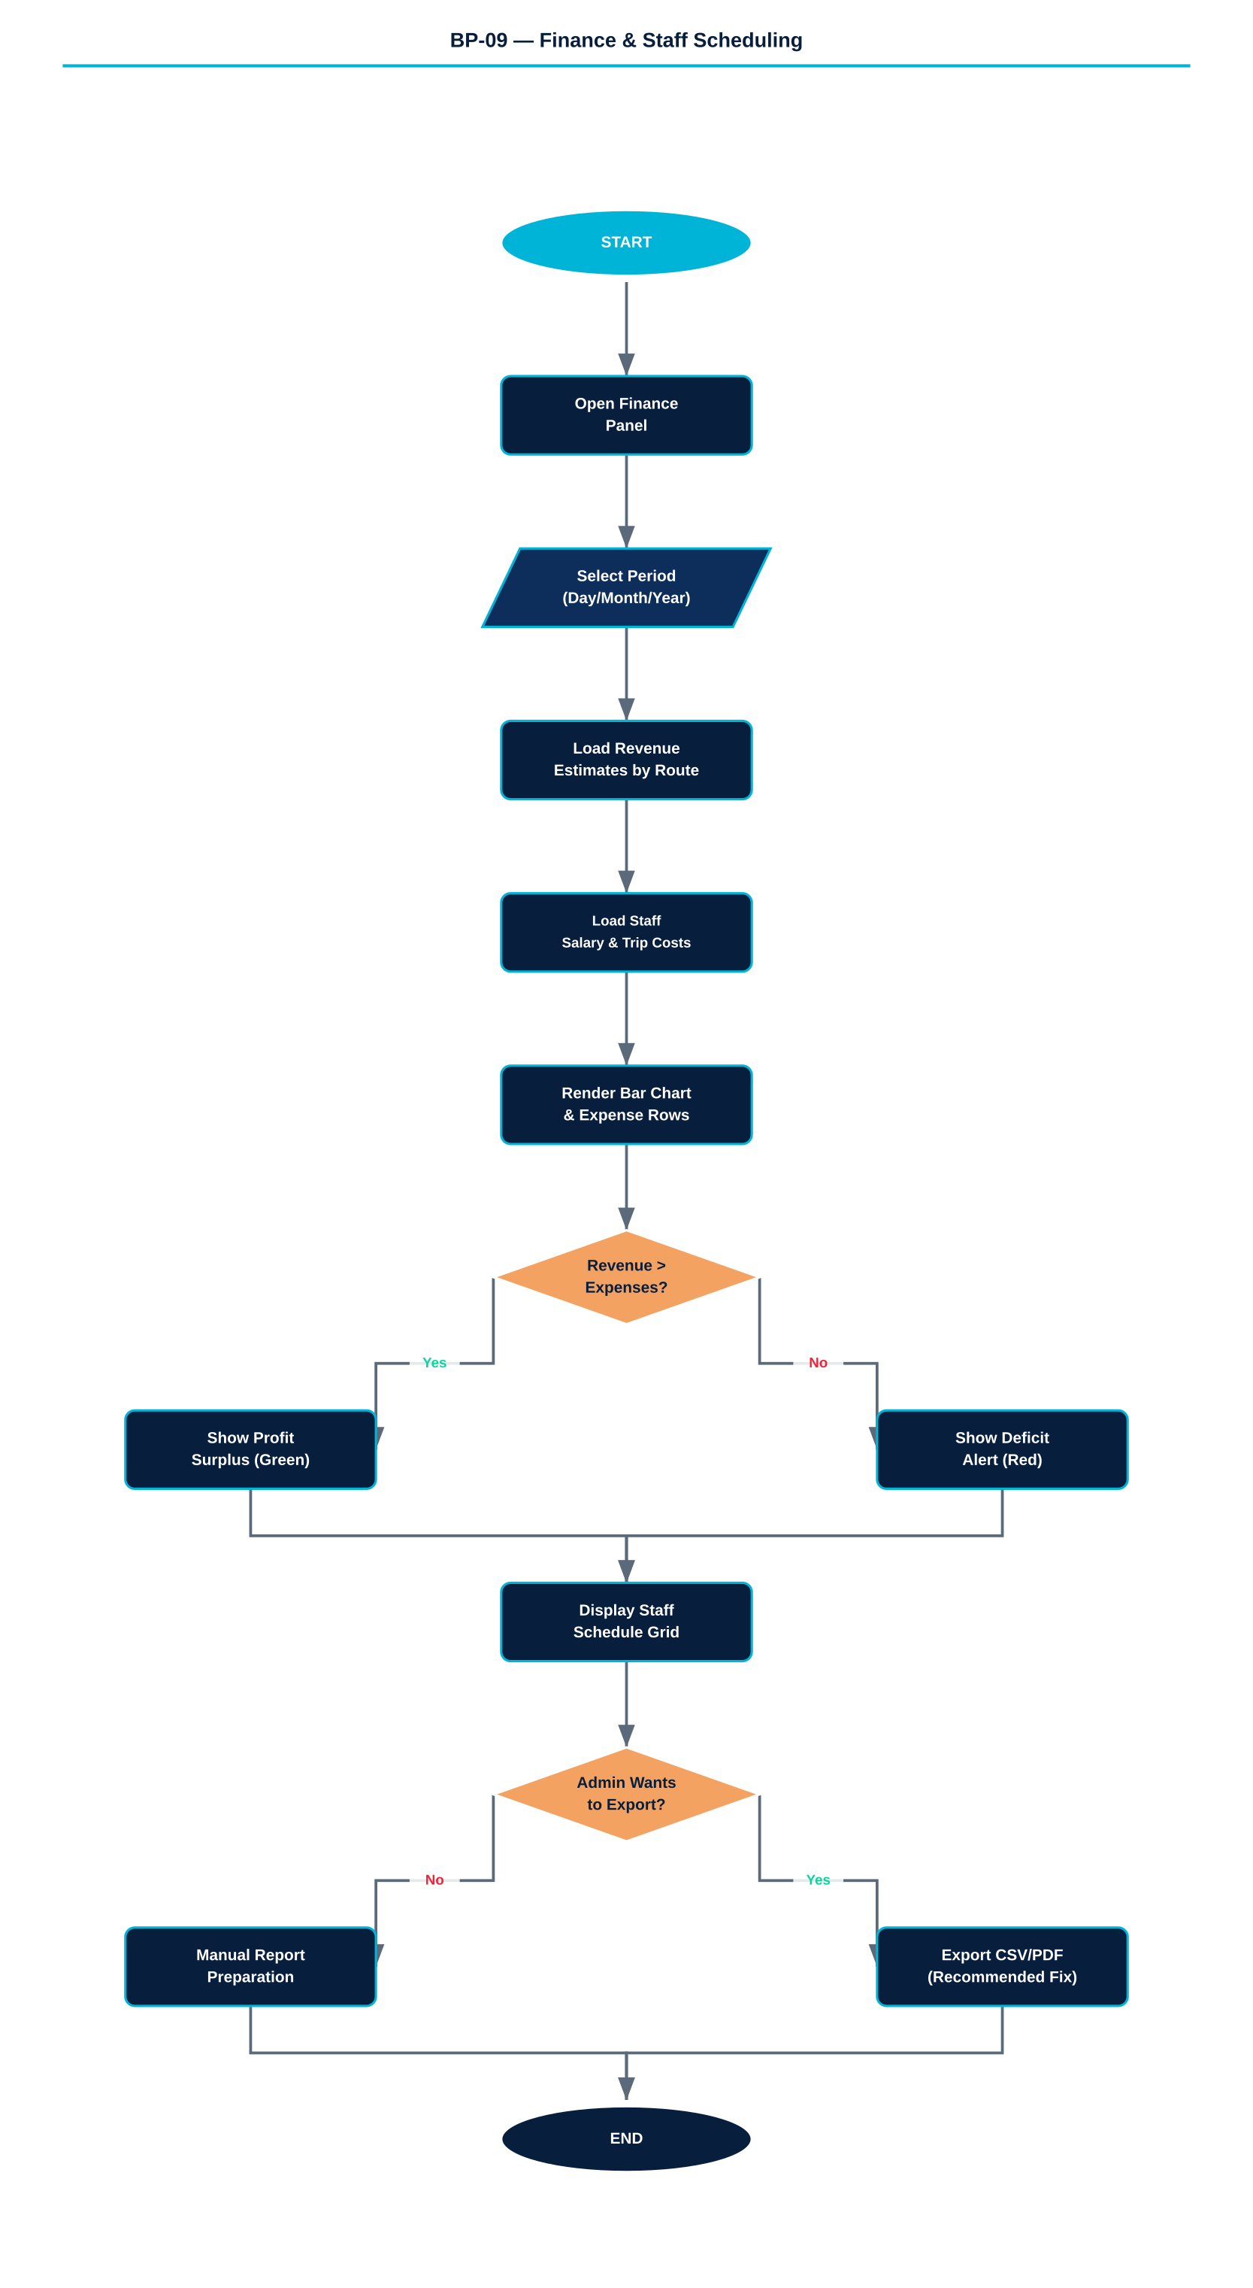

Figure 9 — Finance & Staff Scheduling Yes/No Flowchart

11.2 Revenue Structure
Route | Estimated Daily Revenue (ALL)
TR-HI (Tiranë → Himarë) | 45,000 ALL
TR-SA (Tiranë → Sarandë) | 62,000 ALL
HI-SA (Himarë → Sarandë) | 18,000 ALL
SA-HI (Sarandë → Himarë) | 18,000 ALL
SA-TR (Sarandë → Tiranë) | 62,000 ALL
HI-TR (Himarë → Tiranë) | 45,000 ALL
TOTAL — Daily Revenue | 250,000 ALL (~2,500 EUR)

11.3 Staff Cost Structure
Role | Staff Members | Monthly Salary (ALL)
Manager | Mirela Suli | 80,000
Booking Specialist | Nora Gjoka | 55,000
IT / Web | Oltjon Prifti | 60,000
Accountant | Pranvera Hysa | 58,000
Drivers (×6) | Agron, Bashkim, Çlirim, Dritan, Erion, Fatjon | ~40,000 each
Faturinos (×6) | Gent, Hektor, Ilir, Jona, Klajd, Ledio | ~4,000 / round trip

11.4 Identified Problems
PROBLEM 1: Revenue figures are hardcoded estimates — not calculated from actual booking data.
PROBLEM 2: No dynamic cost modeling for fuel prices, toll fees, or irregular expenses.
PROBLEM 3: Staff scheduling is completely static — no vacation, sick leave, or substitution logic.
PROBLEM 4: Faturino pay is per round-trip but there is no mechanism to track completed trips.
PROBLEM 5: No multi-period comparison — only current period data is shown, no month-on-month.
PROBLEM 6: The bar chart is rendered in static CSS — no real charting library is used.

11.5 Recommended Improvements
FIX 1: Calculate revenue dynamically from the actual booking records in the database.
FIX 2: Add an expense entry form where admins can log fuel, tolls, and ad-hoc costs.
FIX 3: Add a shift management system with leave requests, substitutions, and approval workflow.
FIX 4: Link faturino pay to logged trip completions confirmed by the driver's daily sign-off.
FIX 5: Implement a date-range selector for monthly and yearly revenue trend comparisons.
FIX 6: Integrate Chart.js or Recharts for interactive, animated financial charts.

11.6 User Scenario

Scenario: Accountant reviewing monthly profitability

Pranvera, the TravelFlow accountant, opens the Finance panel on the last day of the month. She selects the monthly view and reviews the revenue bar chart for the past 30 days. She identifies the peak weekend periods and compares them against the salary and fuel cost rows below. The profit box at the bottom shows a positive margin for the month. She notes that the SA-TR and TR-SA routes are the most profitable, while the HI-SA short route barely covers its operational costs. She prepares her monthly report manually — since the platform currently offers no export function — and recommends that the short coastal route receives a fare adjustment or reduced frequency during off-peak weeks.

12. Cross-Process Integration Map

The table below shows how the nine business processes interact with and depend on each other across the platform.

Process Dependency | Integration Point
BP-01 → BP-02 | User must be logged in to complete a booking
BP-02 → BP-03 | Seat selection opens only after trip and stop are chosen
BP-03 → BP-08 | Completed bookings are recorded in Admin > Bookings panel
BP-03 → BP-09 | Booking revenue increments the Finance > Revenue totals
BP-04 → BP-06 | Buses tracked on GPS are the same fleet managed in Maintenance
BP-05 → BP-08 | Rental records appear in Admin > Rentals panel
BP-05 → BP-09 | Rental income is included in Finance revenue calculations
BP-06 → BP-08 | Maintenance status shown in Admin Dashboard vehicle summary
BP-07 → BP-02 | Tourist Guide destinations correspond to bookable route stops
BP-08 → BP-01 | Admin can view, promote, or deactivate user accounts
BP-09 → BP-06 | Staff scheduling feeds into maintenance windows (drivers off = service possible)

13. Overall System Architecture Weaknesses

Beyond process-specific issues, the following architectural weaknesses apply to the TravelFlow platform as a whole.

CRITICAL: All data is stored in browser localStorage — single device, single user, no cross-device persistence.
CRITICAL: No backend server exists — the entire application logic runs client-side, making it insecure.
CRITICAL: Payment processing is fully simulated — no real financial transaction occurs.
HIGH: Role-based access control exists only in JavaScript — it can be bypassed via browser console.
HIGH: No data validation on the server side — all input sanitization must be done client-side.
MEDIUM: The application is a single HTML file — no modular architecture, difficult to maintain at scale.
MEDIUM: No error recovery mechanism — if localStorage is cleared, all data and bookings are lost.
LOW: No analytics or telemetry — no way to track user behavior or optimize the booking funnel.

13.1 Recommended Architecture Upgrade Path
Phase | Timeline | Key Actions
Phase 1 — Backend Foundation | Months 1–2 | Node.js + Express API, PostgreSQL database, JWT auth, cloud deployment
Phase 2 — Data Migration | Month 2–3 | Migrate all localStorage data to database schema; implement full CRUD APIs
Phase 3 — Payment | Month 3 | Integrate Stripe or Albanian bank payment gateway; add invoice generation
Phase 4 — Real GPS | Month 4 | Equip buses with GPS hardware; implement WebSocket live position push
Phase 5 — Mobile App | Months 5–6 | Build React Native driver app for GPS reporting; build client app for e-tickets
Phase 6 — Analytics | Month 6+ | Integrate Mixpanel or custom analytics; add revenue forecasting

